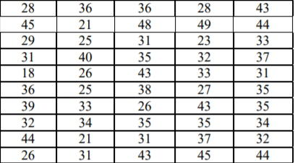

1. 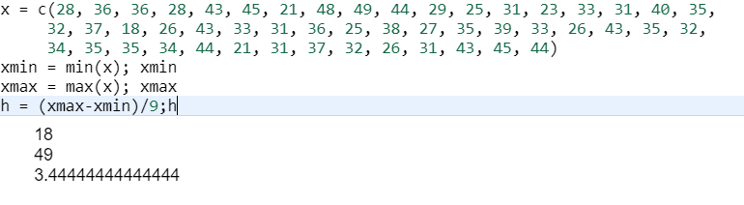

2.

|  |  |  |  |  |  |  |  |  |  |
| --- | --- | --- | --- | --- | --- | --- | --- | --- | --- |
| (xi,xi+1) | 16-20 | 20-24 | 24-28 | 28-32 | 32-36 | 36-40 | 40-44 | 44-48 | 48-52 |
| ni | 1 | 4 | 6 | 11 | 13 | 4 | 7 | 3 | 1 |

Объем выборки n равен 1+4+6+11+13+4+7+3+1= 50

|  |  |  |  |  |  |  |  |  |  |
| --- | --- | --- | --- | --- | --- | --- | --- | --- | --- |
| (xi,xi+1) | 16-20 | 20-24 | 24-28 | 28-32 | 32-36 | 36-40 | 40-44 | 44-48 | 48-52 |
| ni/n | 0.06 | 0.04 | 0.12 | 0.06 | 0.26 | 0.24 | 0.06 | 0.12 | 0.04 |

|  |  |  |  |  |  |  |  |  |  |
| --- | --- | --- | --- | --- | --- | --- | --- | --- | --- |
| xi | 18 | 22 | 26 | 30 | 34 | 38 | 42 | 46 | 50 |
| ni/n | 0.06 | 0.04 | 0.12 | 0.06 | 0.26 | 0.24 | 0.06 | 0.12 | 0.04 |

Накопленные частоты

|  |  |  |  |  |  |  |  |  |  |
| --- | --- | --- | --- | --- | --- | --- | --- | --- | --- |
| xi | 18 | 22 | 26 | 30 | 34 | 38 | 42 | 46 | 50 |
| ni | 1 | 5 | 11 | 22 | 35 | 39 | 46 | 49 | 50 |
| ni/n | 0.06 | 0.1 | 0.22 | 0.28 | 0.54 | 0.78 | 0.84 | 0.96 | 1 |

3. Полигон относительных частот соответствует графику плотности распределения, кумулята соответствует функции распределения



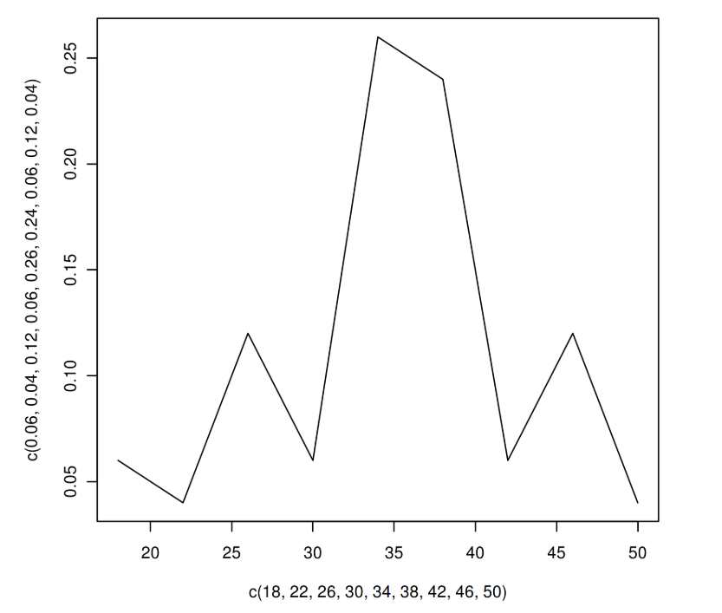

4.

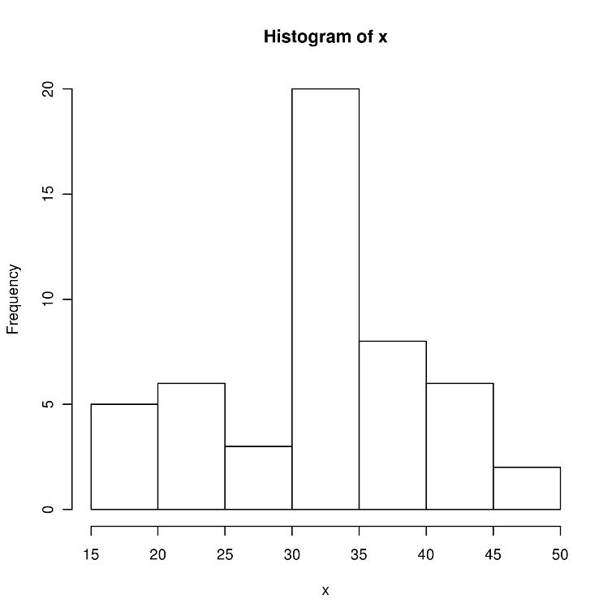

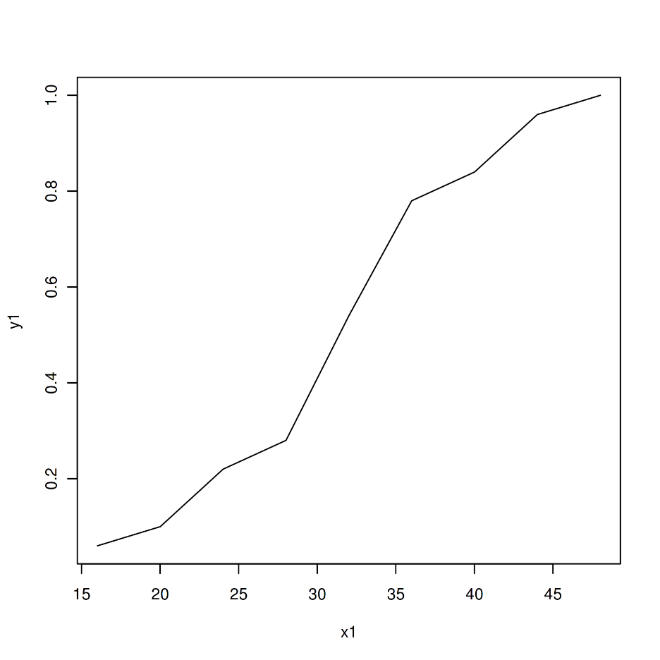

5. 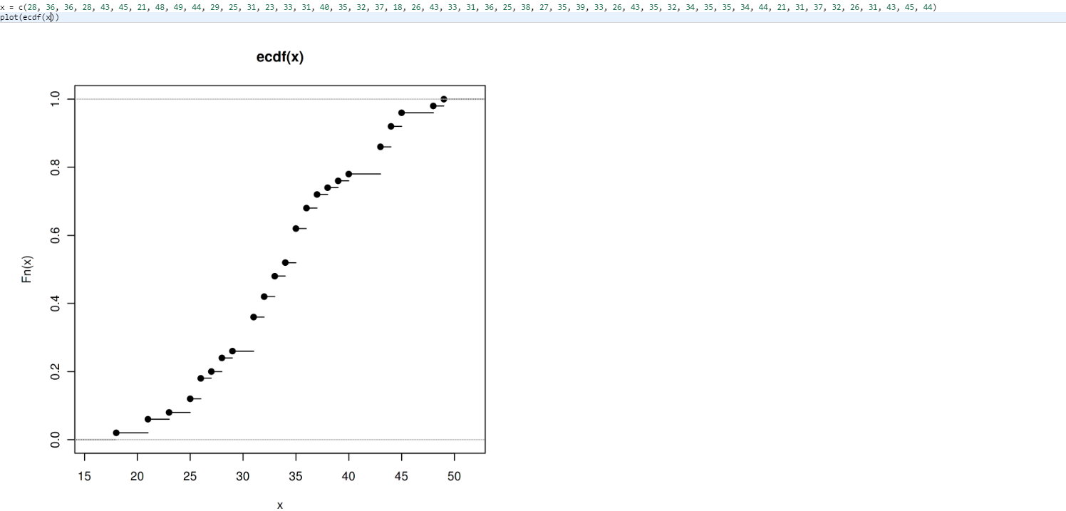

Мода.



Медиана.

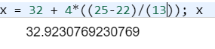

|  |  |  |  |  |  |  |  |
| --- | --- | --- | --- | --- | --- | --- | --- |
| xi | ni | ui | Ni*ui | Ni*ui*ui | Ni*ui^3 | Ni*ui^4 | Ni*(ui+1)^4 |
| 18 | 1 | -4 | -4 | 16 | -64 | 256 | 81 |
| 22 | 4 | -3 | -12 | 36 | -108 | 324 | 64 |
| 26 | 6 | -2 | -12 | 25 | -50 | 100 | 6 |
| 30 | 11 | -1 | -11 | 11 | -11 | 11 | 11 |
| 34 | 13 | 0 | 0 | 0 | 0 | 0 | 0 |
| 38 | 4 | 1 | 4 | 4 | 4 | 4 | 64 |
| 42 | 7 | 2 | 14 | 28 | 56 | 112 | 567 |
| 46 | 3 | 3 | 9 | 27 | 81 | 243 | 768 |
| 50 | 1 | 4 | 4 | 16 | 64 | 256 | 625 |
| sum | 50 |  | -8 | 163 | -28 | 1306 | 2186 |

В качестве ложного нуля принимаем С= 34. Шаг выборки h=4. Тогда условные варианты определяются по формуле. Ui = (xi – 34)/4

M*1 = -8/50 = -0,16

M*2 = 163/50 = 3.26

XВ = M*1 *h + C = -0.16* 4 + 34 = 33.36

Dв = (M*2 – (M*1)^2) * h^2 = (3.26 – 0.0256) * 16 = 51.7504

выборочное среднее квадратическое отклонение: sqrt(Dв) = 7.1937

M*3 = -0.7

M*4 = 32.65

m3 = (M*3 – 3* M*1* M*2+2* (M*1)^3)*h^3 = ( -0.7 – 3 *- 0.16 * 3.26 + 2 * (-0,004096)) * 64 = 55.35

m4 = (M*4 – 4 * M*1 * M*3 + 6 * (M*1)^2 * M*2 – 3 * (M*1)^4) * h^4 = (32.65 – 4 * -0.16 * -0.7 + 6 * 0,0256 * 3.26 – 3 *0,00065536) * 256 = 8256,027

as = m3 / 8.2437 ^ 3 = 0,011984

ek  = m4 / / 8.2437 ^ 4 – 3 = -1,2123

v = 8.2437 / 33 * 100% = 24.39%

6.

|  |  |  |  |  |  |
| --- | --- | --- | --- | --- | --- |
| xi | ni | Xi – xв = xi - 33 | Ui = xi – 33/ 8.2437 | Ф(ui) | Ni = 19.4 * ф(ui) |
| 18 | 1 | -15 | -1,819 | 0.0499 | 1.22754≈1 |
| 22 | 4 | -11 | -1,334 | 0.1127 | 2.77242≈3 |
| 26 | 6 | -7 | -0,849 | 0.2179 | 5.36034≈5 |
| 30 | 11 | -3 | -0,363 | 0.3312 | 8.14752≈8 |
| 34 | 13 | 1 | 0,121 | 0.3961 | 9.74406≈10 |
| 38 | 4 | 5 | 0,606 | 0,3739 | 9.19794≈9 |
| 42 | 7 | 9 | 1,091 | 0.2756 | 6.77976≈7 |
| 46 | 3 | 13 | 1,576 | 0.1604 | 3.94584 ≈4 |
| 50 | 1 | 17 | 2,062 | 0.0734 | 1.80564≈2 |
|  | 50 |  |  |  | 49 |

Ni=50*4/8.2437=24.2

7.

|  |  |  |  |  |  |  |
| --- | --- | --- | --- | --- | --- | --- |
| ni | n,i | ni - n,i | (ni - n,i)^2 | (ni - n,i)^2/ n,i | ni^2 | ni^2/ n,i |
| 1 | 1 | 0 | 0 | 0 | 1 | 1 |
| 4 | 3 | 1 | 1 | 0.3333 | 15 | 5 |
| 6 | 5 | 1 | 1 | 0.2 | 36 | 7.2 |
| 11 | 12 | -1 | 1 | 0.142 | 121 | 11 |
| 13 | 13 | 0 | 0 | 0 | 169 | 13 |
| 4 | 5 | -1 | 1 | 0.142 | 16 | 4 |
| 7 | 6 | -1 | 1 | 0.2 | 49 | 7 |
| 3 | 4 | -1 | 1 | 0.33333 | 9 | 3 |
| 1 | 1 | 2 | 4 | 4 | 1 | 2 |
|  | 50 |  |  | 5.352 |  | 53.2 |

Контроль

53.2 – 50 =3.2

число степени свободы

v = s – 3 = 9 – 3 = 6